

[Replace w/ picture of our saw]
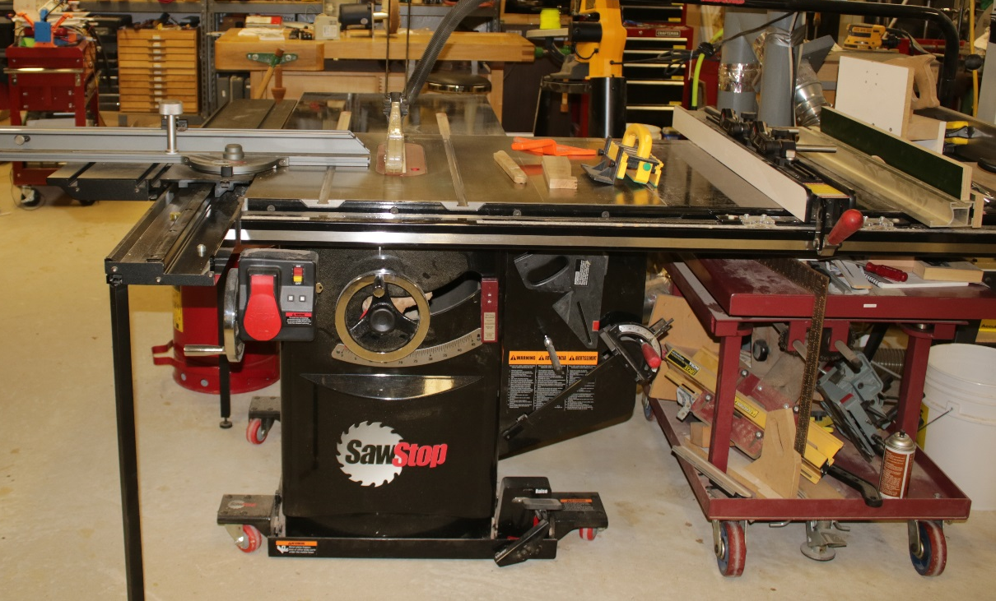

Table Saw Use and Safety
By Norm Brewer, Philip Gaudette, Krista Nugent, Ka-Loon Tung, Dave Bennett

Table of Contents

Introduction

Parts of the Table Saw

General Shop Safety Tips

Table Saw Safety Check List

Safer Tools for Cutting Wood

Table Saw Setup

Accessories and Jigs

Types of Cuts

Wood Working Tools We Can Train You to Use

References

Introduction

This course is intended to teach you the basics of safety using the table saw here at Nova Labs. It is not a complete guide to the table saw. Please note that this document is not intended in any way to be a substitute for training, in person, in the shop. The course is based on The Table Saw Book by Kelly Mehler and you are expected to purchase and read that book before taking this course. This is a prerequisite to being certified on the Nova Labs tablesaw.

The table saw is inherently one of the most dangerous tools in the shop. If you have not received training on the table saw, please do not use the table saw!

Sawstop Table Saw
Nova Labs has recently purchased a Sawstop tablesaw. This saw has important safety features to reduce the severity of injuries that the tablesaw can inflict if you accidentally touch the blade. The Sawstop senses when electrically conductive materials (such as your hand) touch the blade and it fires an aluminum stop block into the blade. This destroys the blade and cartridge, and will cause several hundred dollars’ worth of damage if it happens. The Sawstop is not a substitute for safety training, and you can still get hurt on using it if you are not careful. The table saw can pick up pieces and throw them violently back at you (kickback), while simultaneously dragging your hand over the blade. You always need to focus your attention completely on what you are doing while you are using the table saw.

You will learn:

Parts of the table saw

General shop safety

Table saw safety

Safer tools for cutting wood

Set-up of the table saw

Accessories and jigs

Types of cuts on the table saw

Wood working tools we can train you to use

Parts of the Table Saw [add text to these?]

Cabinet (p. 18)

Table and extensions (p. 6)

Throat plate (p.9)

Rip fence (p. 6)

Miter gauge and slots (p. 6)

Arbor (p. 51)

Adjustment hand wheels (p. 6)

Power switch (p. 6)

Riving knife/splitter (p. 15)

Anti-kickback fingers (p. 15)

Safety wheels (p. 77)

Table saw blades, design and anatomy (p. 45)

Teeth (p. 47)

Rake and bevel angle (p. 49)

General Shop Safety Tips [Use green box on page 63]

Always think about the direction you are pushing your hands while you are working on a power tool. Ask yourself, “If your hands slip (or the work piece slips or breaks), will they go into harm's way?” If so, stop and rethink your body position.

Don't stand right in front of a blade that can kickback and throw the material you are cutting at you.

Make sure you can reach the “STOP” button quickly if something goes wrong.

Always wear personal protective equipment. (pp. 80-81)

Kickback [Green box on page 65]

This video shows the hidden dangers of kickback on the table saw [add video link here]

Ejection [paraphrase from page 64]

Laceration [from p. 66]

First-aid for eye injuries [use green box p. 83]

Dust collection (p. 114)

Table Saw Safety Checklist

Leave the guards in place whenever you can. Nothing good ever comes from removing them.

Never use both a miter gauge and the rip fence at the same time. The work piece can bind and cause a kickback.

Never attempt freehand cuts. Always use the rip fence, miter gauge, or a sled.

Only cut wood and soft materials such as acrylic or phenolic plastic. Never cut aluminum or any metal!

Unplug the saw before changing the blade.

Always use a throat plate, preferably one with a built-in splitter.

Keep the blade low, just high enough to clear blade gullet.

Keep your fingers at least 1 finger length (3”) away from the blade at all times. Use pushers/push sticks to maintain separation and control of the work piece.

Never cut pieces less than 12 ” in length without a jig.

Do not cut boards with loose knots. The knot can come loose and be hurled at you with tremendous force. Use ‘Safer Tools for Cutting Wood’ for these cuts.

Never reach over the blade while it is spinning.

Lower the blade below the table when finished using the table saw.

Support long pieces with auxiliary support (out feed table p. 119) in front of and behind the blade to minimize the force necessary to keep your work safely under control.

When removing small amounts of wood, several passes that create sawdust are safer than one pass that can kickback small pieces.

Safer Tools for Cutting Wood

There are many jigs, guards, and technological innovations that help make the table saw safer. But one simple step is to use ‘Safer Tools for Cutting Wood’ than a table saw when appropriate.

The band saw is safer because it doesn’t kickback. The cutting force is directed down towards the table. For many cuts, the band saw should be the tool of choice. Nova Labs has several band saws with various blade widths for different cutting tasks.

The chop saw (also called a miter saw) is safer and more appropriate for cutting long pieces like 2 x 4 studs. With the chop saw, auxiliary supports, and clamps, it is easy to keep your hands out of harm’s way. The work piece remains stationary, and you don’t have to slide a heavy work piece over the table as you do on the table saw.

The handheld circular saw and straight edge combination is often a good alternative to the table saw for cutting large panels such as a sheet of plywood. One drawback of the circular saw is that it may not produce as clean a cut as the table saw. You can always cut a piece oversized, and once you have cut it to a safer size, then use the table saw to trim the edges and make splinter free cuts. This avoids the problem of handling a large panel on the table saw.

The router [add text]

Table Saw Set-up

The Nova Labs table saw is kept in good condition. However, it is a shared facility, and you should not rely on anything being set correctly. You must know how to make all the common set-up adjustments to safely use the table saw. Check the set-up before every use.
Blade Types:
Combination blades can be used for both cross cuts and ripping, but are not ideal for either use. They do let you avoid constantly changing blades during a project; this type of blade is normally on the Nova Labs table saw.
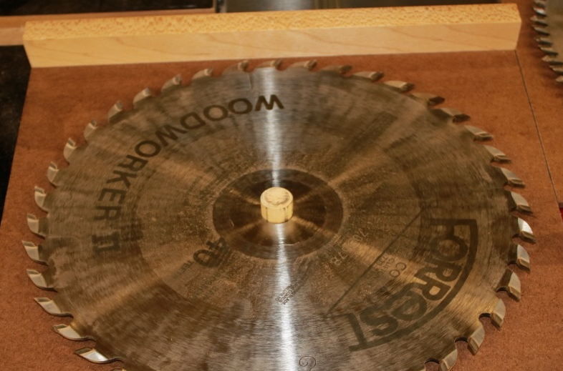
Forrest Woodworker II 40 tooth combination blade
Crosscut blades have many small teeth and produce a very fine cut when crosscutting. There are many different tooth patterns available, and they may not produce a flat-bottomed kerf.
Rip blades generally have fewer teeth and bigger gullets for clearing out sawdust. Rip blades are made for cutting with the grain, and tend to cut more cleanly and with less power than crosscut blades, and the teeth normally have a flat-top grind. If you have a lot of ripping to do or are ripping woods that are prone to burning like maple and cherry, you should consider changing to a specialized rip blade. Some
rip blades may be more narrow than the standard 1/8” blade. If you need a flat-topped kerf, you might
consider using a rip blade

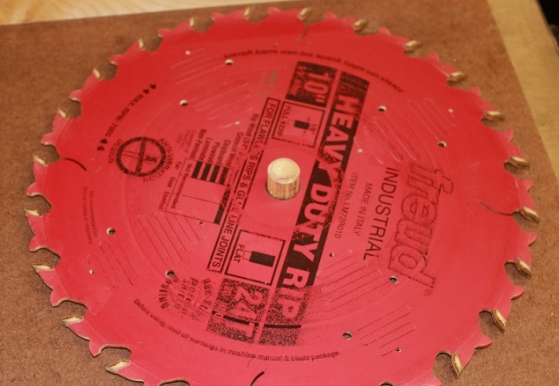
Rip Blade - Fewer flat-topped teeth, deep gullets
Stack dados consist of two outer cutters, between which are sandwiched a number of chippers that produce a kerf from ¼” wide to ¾”+. Normally, the outside blades are 1/8” wide, and there are both 1/8” and 1/16” chippers. You can fine tune the width of the dado stack using paper, plastic, or metal shims.
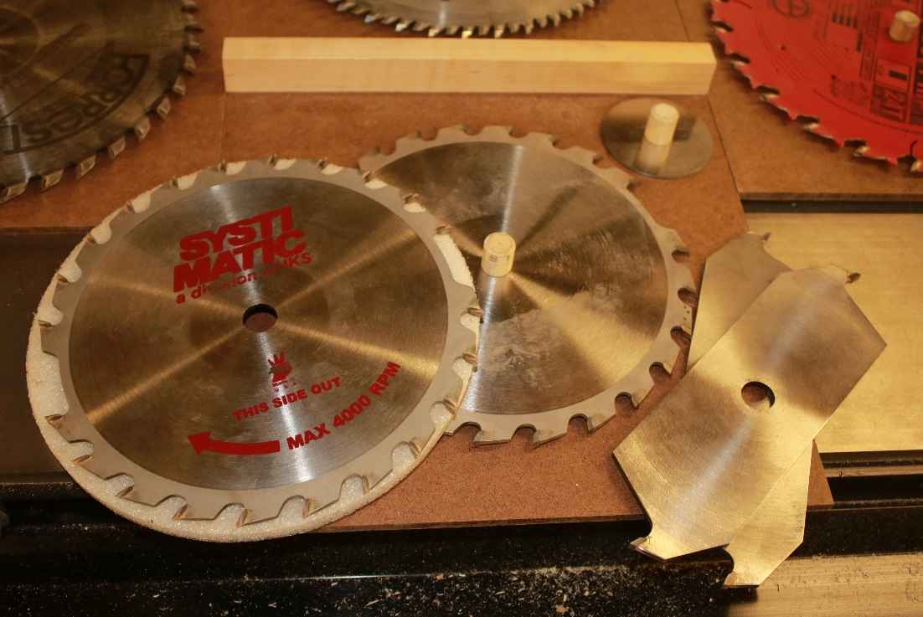
Stack Dado set
Wobble dado (p. 56) [add text]

Specialty blades (p. 54) can produce very thin or thick cuts, and are designed for specialty joints like box joints.
Blade angle and height adjustments (p. 127) There are large hand wheels on the front and left side of the table saw. Each hand wheel has a locking knob in the center which must be loosened (counter clockwise) before making an adjustment. The front hand wheel sets the blade height, and the left side hand wheel sets the blade tilt. Clockwise motion on each hand wheel raises the blade or tilts the blade away from vertical. There is a positive stop on the blade tilt angled at 90⁰ and 45⁰, and there is also an indicator on the front of the saw that shows the approximate tilt. Tighten the locking knobs when finished making an adjustment or the adjustments may drift during use

Aligning the miter gauge slot to the blade (p. 100) There is no easy adjustment for this and calibration involves loosening and adjusting the whole table saw top. However, a quick check with a square should show that the miter gauge is square to the blade. If it is not, do not use the table saw, and ask one of the shop stewards to help correct it.

Adjusting the rip fence (p. 105) When you lock the fence to the table saw, it should be parallel to the miter gauge slots. Move the fence just to the right or left of a miter gauge slot and clamp it in place. You can then visually check that it is parallel to the slot. If it is not, do not use the table saw, and ask one of the shop stewards to help correct it.

Selecting the right blade for the task and verifying the teeth are in correct orientation (p. 50) The correct blade installed with correct orientation is a must for a clean and safe cut. It is possible to put a blade on backwards. See blade installation p. 50.

Dust collectors (p. 117) Verify the dust collector is securely connected on both ends and operating correctly before each cut.

Auxiliary support (Out feed table) (p. 119) [add text]

Pushers/push sticks (p. 79) are necessary and should be within easy reach to complete a cut safely. [add better description]

Do not rely on rip fence markings. You should always cut a piece of scrap to check the accuracy of the fence setting.

Adjusting the miter gauge (p. 107) Set and lock the miter gauge to be the angle you desire and make a test cut.

Throat plate (p. 98) [add text]

Changing the Blade (p. 51)
The Nova Labs table saw has a 5/8” arbor that is not removable. First, the power cord should be unplugged. Use the 2 wrenches provided on left side of the saw, one wrench is used on the flats of the arbor, the other wrench is for the arbor nut .The correct sequence for removing the blade is:
Throat plate
Nut
Washer
Stabilizer
Blade
Flange (not often removed)

The correct sequence for installing a blade is:

Flange
Blade – with teeth oriented correctly. Spin blade by hand to verify it moves freely.
Stabilizer
Washer
Nut
Throat plate

[Insert picture of our saw, label all parts correctly]
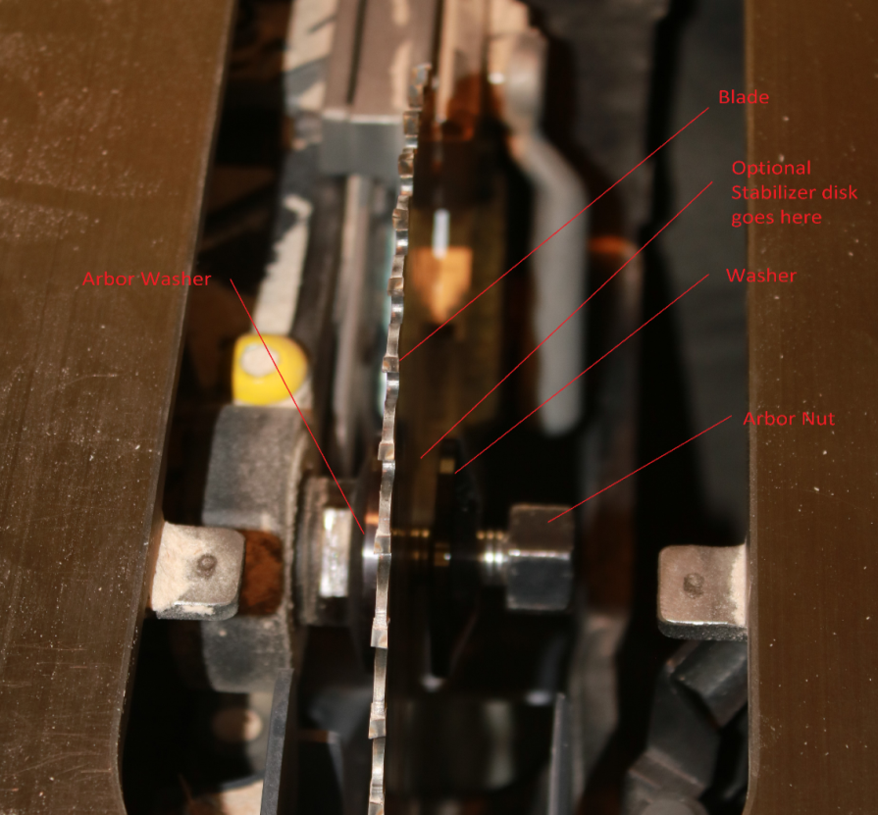
Table saw arbor, flange, blade, stabilizer, washer, and nut

Accessories and Jigs

Pusher blocks and push sticks will keep your fingers away from the blade and help hold the work piece against the table and rip fence. There are a variety of these available at Nova Labs, or you can make your own out of scrap we have on hand. Bigger is generally better.

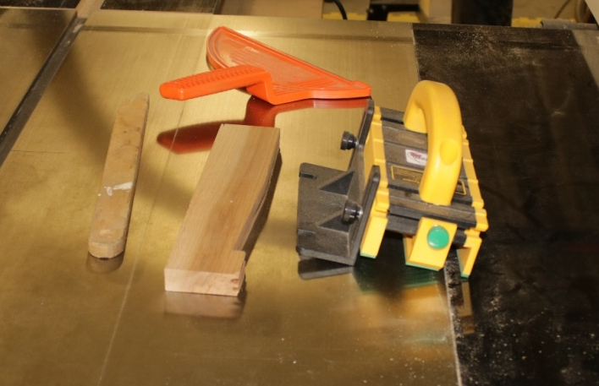
Pusher Sticks, blocks, and Gripper hold down
Feather boards and magnetic hold-downs (p. 77) These accessories hold the work piece against the table and rip fence. They should only be used on the in-feed side of the blade.
If they are placed incorrectly, a kickback will occur.

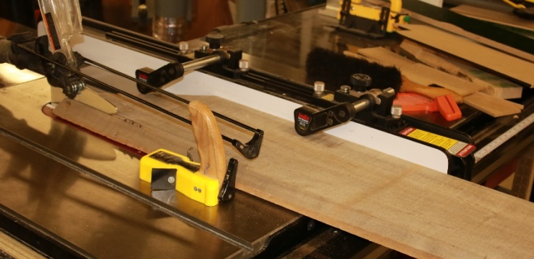
Magnetic feather board (Griptite).
Zero clearance throat plates (p. 100) These accessories improve the quality of the cut by minimizing splintering on the bottom of the work piece and keeping thin cutoffs from falling into the table saw.

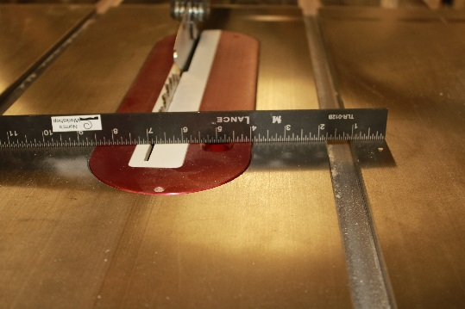
Zero clearance throat plate
Crosscut sleds are accessories that make cross cutting of larger pieces easier and safer, and will improve cut quality. They have a back fence that is adjusted 90⁰ to the blade. The one shown below has a zero clearance both below and behind the blade. It also has a guard that comes out of the back of the sled to keep your fingers safer from the blade. It has a swinging stop to make multiple cuts of the same length safer and more accurate. You can clamp a stop to most crosscut sleds to act as a length stop if not already built in.

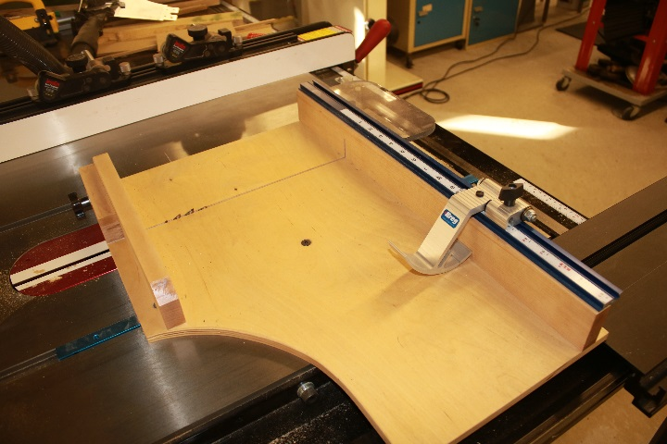
crosscut sled

Miter gauges help guide the work piece through the blade, and can be set for miter cuts of various angles.

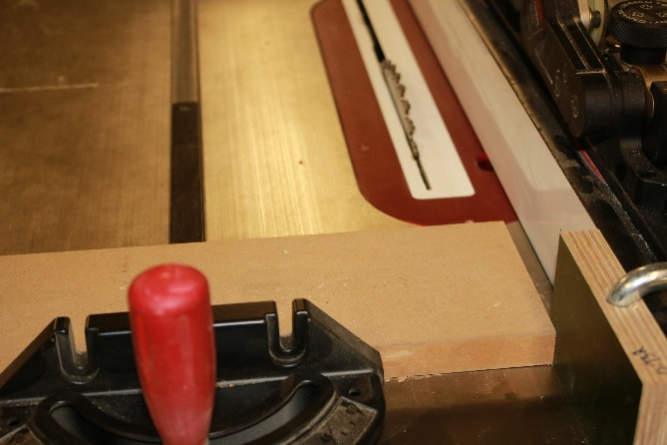
Miter gauge being used with stop block to avoid kickback
DO NOT USE THE MITER GAUGE AND RIP FENCE TOGETHER WITHOUT A STOP BLOCK!

Tenoning jigs hold work pieces vertically enabling you to make tenons on the end of work pieces.

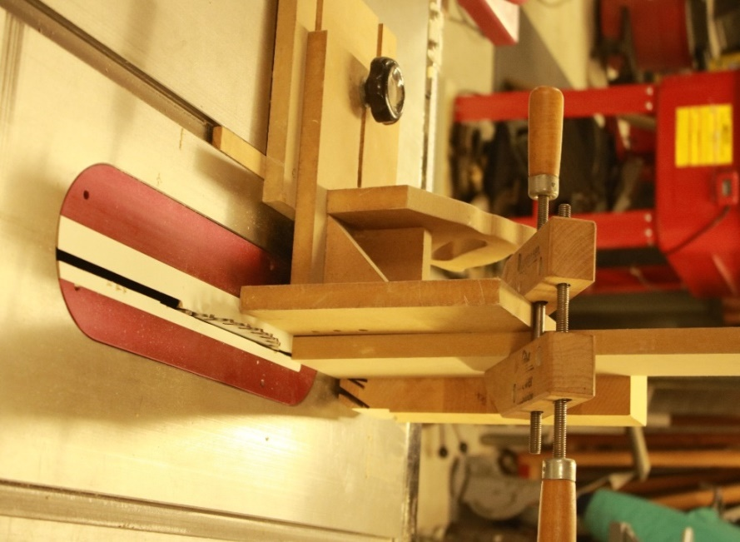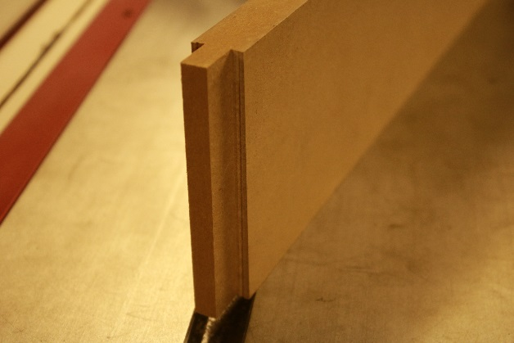
Shop made tenoning jig and a tenon cut

Sacrificial fences keep the blade from damaging the rip fence. They are clamped against the rip fence to allow part of the blade or dado stack to be buried in the sacrificial fence. Always clamp a sacrificial fence to the rip fence if you need to cut close to the fence.

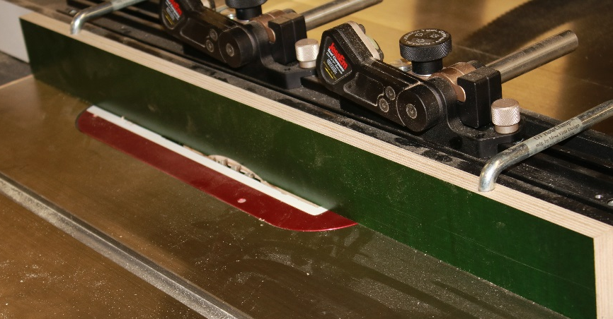
Sacrificial fence with blade partially buried in it

Tapering jig [add text]
Stops [add text]
Auxiliary support (out feed table) (p. 119)[add text]

Types of Cuts

Ripping is cutting with the grain making narrow pieces out of wide pieces. It is done by setting the rip fence the desired distance from the blade, and then sliding the work piece along the rip fence. Rip blades are made for cutting with the grain, and tend to cut more cleanly and with less power than crosscut blades. The key to making a safe rip cut is to hold the work piece tightly against the rip fence and tightly down to the table. When you feed the piece into the blade, it has a tendency to ride up onto the blade, which is dangerous. Use a slow feed rate and feather blocks to keep the work piece tight against the table. Make sure you have a pusher/push stick to move the work piece into the blade.
If you have to rip a piece shorter than 12”, consider ‘Safer Tools for Cutting Wood’ to make the cut. For example, use a sled and hold down, as shown below.

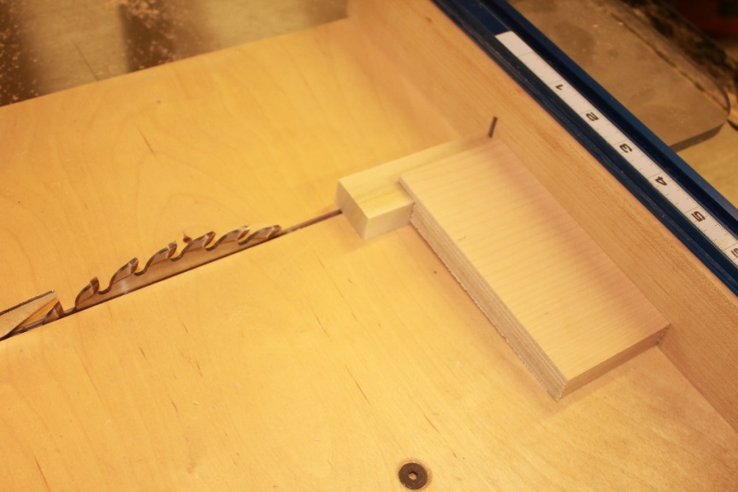
Hold down used on sled to rip a short piece
Safely ripping thin pieces. When you rip thin strips against the rip fence, they will get trapped between the blade and rip fence. This will cause kickback by the friction of the blade rubbing on the side of the piece. To avoid this you can set a stop block to the left of the blade at the desired distance, then set the left side of the work piece against this stop. The photos below show a “thin strip rip guide” creating a ¼” strip.

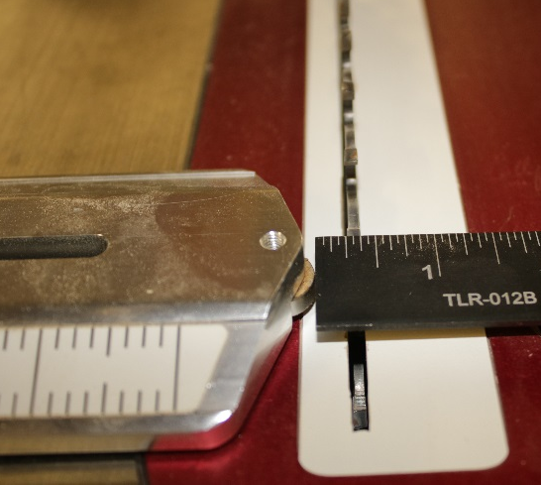
Thin strip ripping jig

[beginning students should be encouraged to use only dressed lumber]
[consider removing this paragraph from this instructional course]
Ripping wood with live edge. Some boards come from the saw mill with the bark or live edge still on the board, and this edge is often not straight or uniform. The safest way to make one edge of a board straight is to use either the jointer (if you are certified) or the band saw (if you are certified). If you use the band saw first, joint the band sawn edge to make it straight, and then rip the board to the desired width. You can also tack a straight edge to the board and use that against the rip fence to saw one straight edge.

Bevel cuts. This is a rip cut with the blade tilted. The Nova Labs table saw is a left-tilt machine so the top of the blade tilts to the left as you change the angle from vertical. Do not move the fence closer than about ¼ inch to the right of the blade when making a beveled rip cut so there is always support on both sides of the work piece, and room for you to push the work piece between the rip fence and blade

Cross cutting is just what it sounds like. You cut longer pieces into shorter pieces. If you cut the ends at 90⁰, it is a standard cross cut. If you cut at a different angle, it is called a mitered cross cut. In either case, you use the miter gauge set to your desired angle to achieve your precise cut.

Dado and rabbit cuts are slots and shoulders of varying widths to accommodate a panel or another piece of wood, and do not extend all the way through a work piece. They are often cut using a stack dado, but you can also make a slot with multiple passes using a standard blade. Since these are not through cuts, you may not be able to use a riving knife/ splitter guard because the blade does not protrude through the work piece. There is an increased risk of a kickback with this type of cut.

Tenon cuts are used to create shoulders on the end of a work piece. Tenons can be cut vertically if there is enough overhead clearance for your work piece. You can also use a dado head and cut a lap joint style tenon if it is too long to use a tenoning jig. See the safety accessories section for more details on the cutting of tenons and the jigs you will use.

Climb cuts [add text]
Stop cuts [add text]

Wood Working Tools That We Can Train You to Use

Red level certification needed:
Band saw
Jointer
Planer

Yellow level certification needed:
Sanders
Lathe
Drill press
Router table
CNC machine
Hollow chisel mortiser

Green level certification needed:
Hand tools

References

The Table Saw Book . Kelly Mehler is a woodworking teacher and has a woodworking school in Berea, Ky. Kelly has been a leading proponent for riving knives, and was instrumental in getting them to be standard on new saws sold in the USA.
Jim Tolpin’s Table Saw Magic. Jim Tolpin.
Practical Safety Devices. Marc Adams gives some great table saw safety tips.
The Incredible L-Fence . Bob Van Dyke. Take your table saw to another level with this simple shop made fence.
Staying Safe on the Table Saw. Marc Adams. Fine Woodworking #233, pp. 30-35, April 2013.

